**Hello World Login Test**

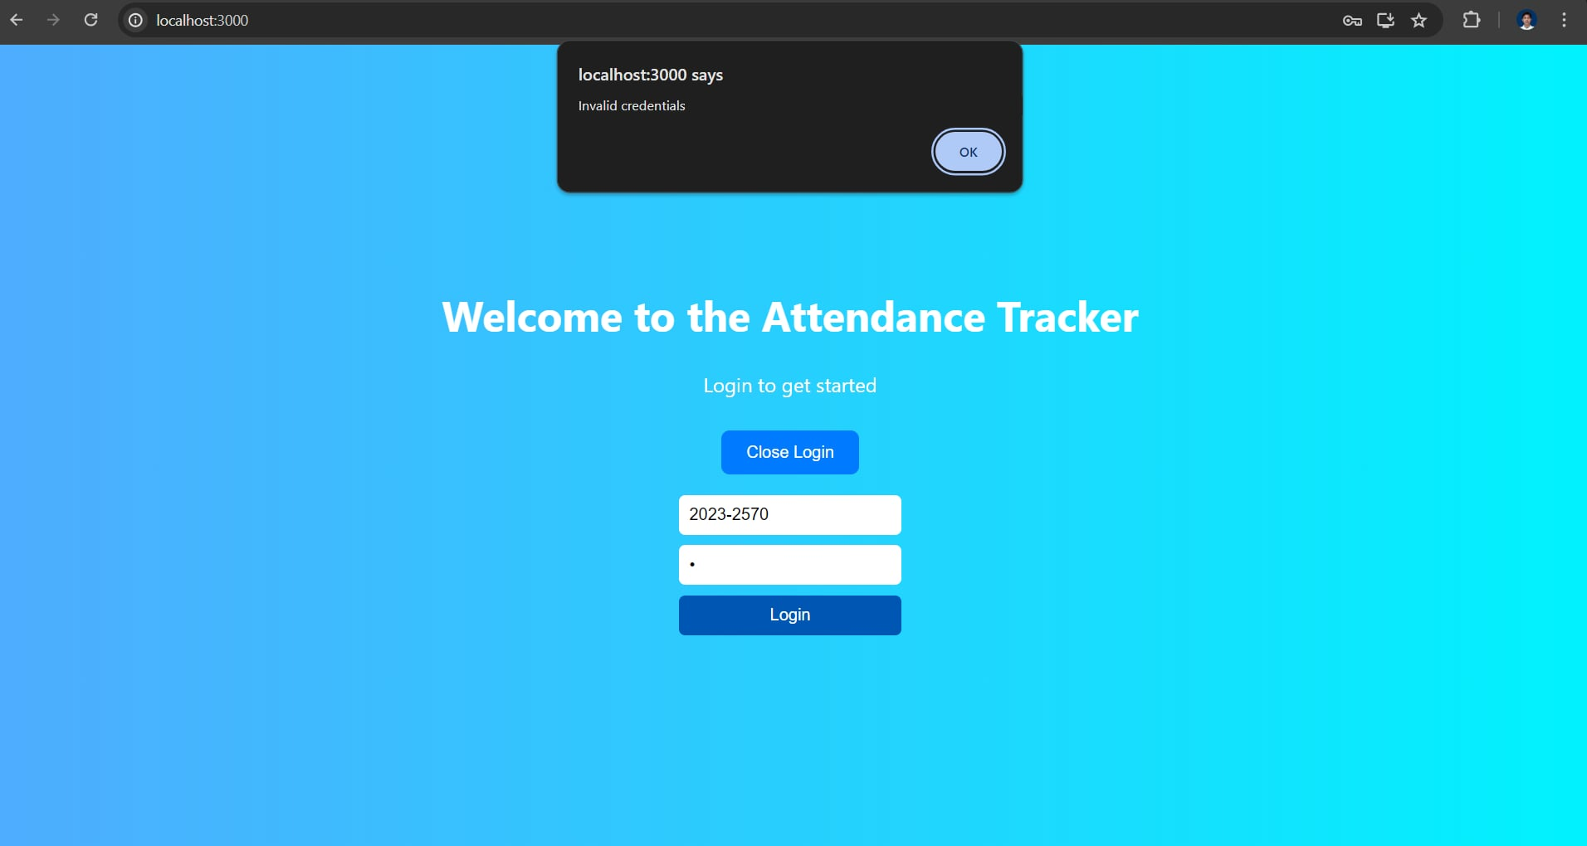  
  
 Web Login with Unregistered User

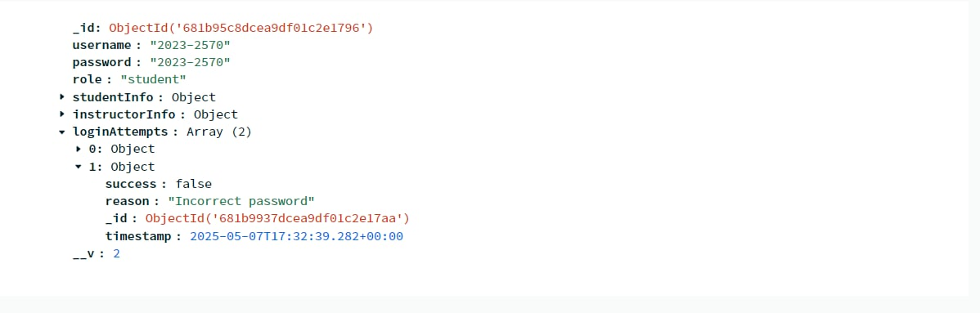Database

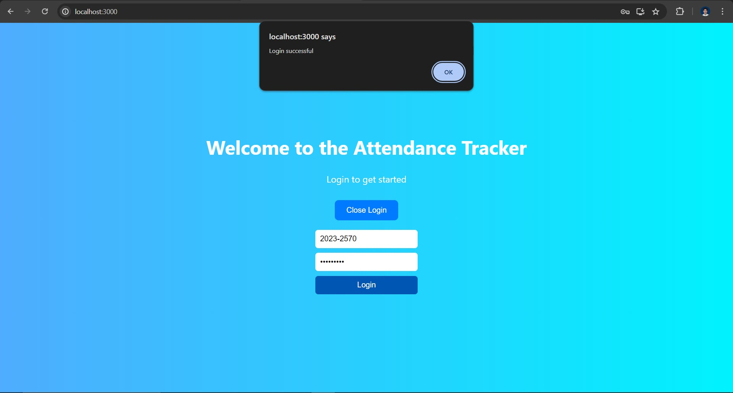Web Login with Registered User

Database

